生物乙醇(bioethanol)技术（现状、问题、研究热点）

清洁能源材料导论，梁彤祥等编著，哈尔滨工业大学出版社，2003

生物质能技术与应用，钱伯章编，科学出版社，2010

0.生物乙醇是什么

1.生物乙醇能用来干什么？

2.为什么要用它 现状（巴西[生产方便]、美国[技术强]、瑞典[环保？] 乙醇汽油燃料的优点）（能源结构）

3.如何制备（纤维素+酶+？、）

4.有什么技术、问题

5.现今研究热点、发展趋势

<https://www.bp.com/content/dam/bp/business-sites/en/global/corporate/pdfs/energy-economics/statistical-review/bp-stats-review-2019-full-report.pdf>

**生物乙醇是生物质能源的一种，先介绍生物质能源**

生物质是什么？

[Biomass](https://www.sciencedirect.com/topics/agricultural-and-biological-sciences/biomass) refers to the mass of living organisms, including plants, animals, and [microorganisms](https://www.sciencedirect.com/topics/earth-and-planetary-sciences/micro-organism), or, from a biochemical perspective, [cellulose](https://www.sciencedirect.com/topics/earth-and-planetary-sciences/cellulose), [lignin](https://www.sciencedirect.com/topics/earth-and-planetary-sciences/lignin), sugars, fats, and proteins.

生物上获取的物质，包含植物、动物、微生物类。其实自古以来人们就开始利用生物质了，即用柴烧火，只是进入工业时代后改为化石能源。

（植物）植物细胞壁的主要组成成分：纤维素cellulose(35% to 50%),半纤维素hemicellulose(20% to 35%),木质素ligin/木质纤维素lignocelluloses(15% to 20%)

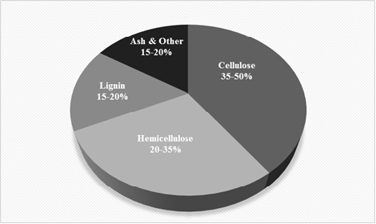

[Madadi M1,2* and Abbas A2,"Lignin Degradation by Fungal Pretreatment: A Review"]

**三者的差别是？**

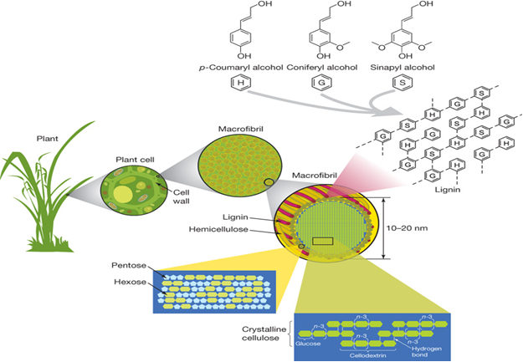

Cellulose is a straight chain polymer containing glucose units, while hemicellulose has an amorphous polymeric structure with several five-carbon and six-carbon sugars as building blocks. Lignin is a complex non-crystalline phenolic macromolecule containing aromatic structures such as sinapyl, coniferyl, and coumaryl alcohols.[Madadi M1,2* and Abbas A2,"Lignin Degradation by Fungal Pretreatment: A Review"]

纤维素是一种以葡萄糖为单元的**直链(且高度结晶的)**聚合物，而半纤维素则是一种**无定形**的聚合物结构，以一些五碳糖和六碳糖为基础结构。木质素是一种复杂的非晶态的酚醛大分子，含有辛那普利sinapyl(S),松柏醇coniferyl(G),和香豆醇coumaryl(H)等芳香族结构。

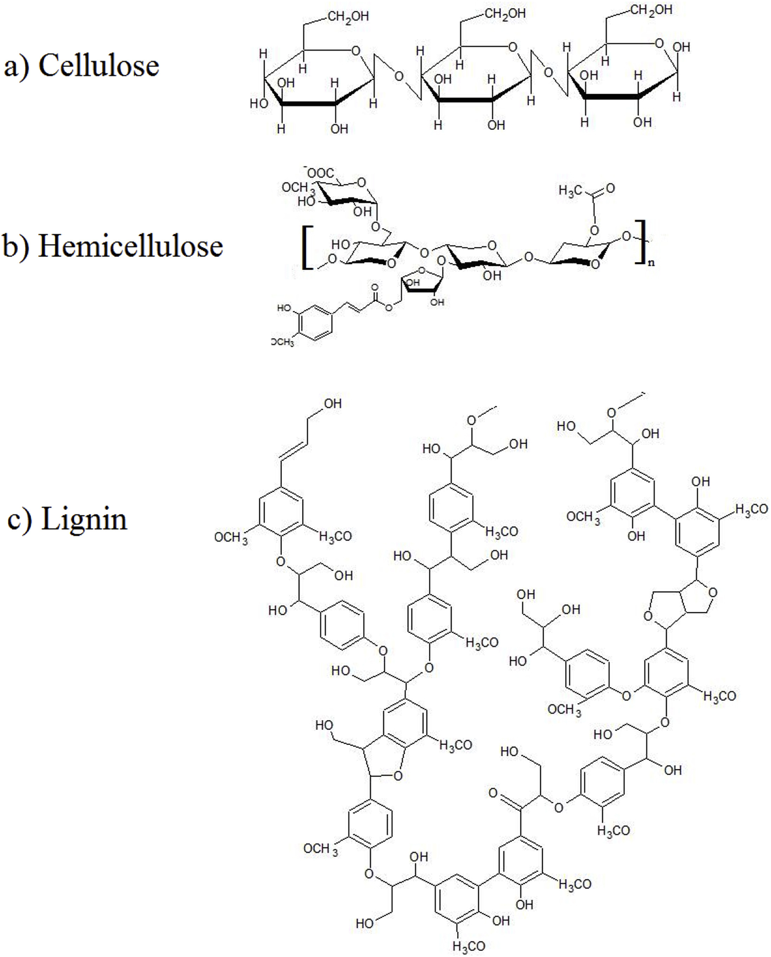

The cellulose strains are connected to each other to deliver cellulose fibril. A number of **intra- and intermolecular hydrogen bonds** are linked between cellulose fibers together. (纤维素靠分子间和分子内氢键互相连接形成纤维)

Hemicellulose is the second plentiful constituent of lignocellulose, is comprised of diverse pentoses (arabinose, xylose) and hexoses (mannose, galactose, glucose).

**So, that large amount of hemicelluloses must be eliminated to improve the cellulose digestibility for the enzymatic hydrolysis.**

半纤维素是木质纤维素的第二大组成，由不同的五碳糖（阿拉伯糖、木糖）和六碳糖（甘露糖、半乳糖、葡萄糖）组成。为了提高纤维素的消化率，必须去除大量的半纤维素。

Lignin primarily is consisted of p-coumaryl phenol (H), guaiacyl (G) and sinapyl alcohol (S). Polymerization of these constituents mainly synthesize lignin and their proportion is different between crops, woody plants and also in the primary and secondary cell wall. Microfibrils formed by cellulose,hemicellulose and lignin, which make intensity in the plant cell wall.

In plant cell wall, hemicelluloses, and lignin

secure cellulose.（半纤维素和木质素保护着纤维素） Hence, it reduces surface area available for enzymatic hydrolysis. （使酶水解的反应面积减小）Pre-treatment is required to alter the biomass particle size and structure as well as its sub-microscopic chemical composition and structure so that hydrolysis of the carbohydrate fraction to monomeric sugars can be achieved more rapidly and with greater yields.（预处理宏观上就是改变生物质粒子的大小、结构和微观上改变化学组成和结构。使碳氢化合物得水解反应更快、产出更高） An ideal pre-treatment method should be contains many advantages like

biomass size reduction, quick enzymatic hydrolysis with improved

monosaccharide yields and limitation in inhibitor enzymes formation

compounds and reduce energy requirements and low-cost demand.（理想的预处理过程：减小生物质大小，酶水解反应快，单糖产出多，抑制酶生成少，减少外部能量输入和成本低）

Saccharification of lignocellulosic biomass without pretreatment can yield less than 20% of total sugars, while after pretreatment it can rise to 90% with different pre-treatment methods.（预处理的效果）The efficiency of pre-treatment depends on chemical composition,physical structure of the biomass and the treatment requirement [27]. Pre-treatment is probably the most energy intensive operation in biomass conversion to fuels or chemicals. From 1950s cellulose and hemicellulose hydrolysis have been investigated, with the fungus Trichoderma reesei providing as the ideal microorganism [28].

Bioethanol production from lignocellulosic biomass serves as an alternative source of renewable energy. Fine tuning of pre-treatment technologies for different biomass types and development of an economically viable process are still needed. In biological pretreatment for the degradation of lignin the most used microorganisms are brown-,

white- and soft-rot fungi.（预处理的微生物） Using white rot fungi that can decrease lignin seems favourable since they consume less environmental damage and less energy conception. Biological pre-treatment has several advantages over conventional chemical/physical pre-treatment strategies,several challenges need to be addressed before implementing at the commercial scale.（优点和挑战） To address these drawbacks consequential study and improved schemes are required for decreasing the pre-treatment costs and enzymatic hydrolysis procedures, reactor formation to reduce heat production during biological pre-treatment and determination of effective lignin hydrolyzing microbes by using improved molecular systems.（未来发展：1.减少成本包括预处理、水解、减少热生成的反应器，2.寻找高效的微生物）

|  |  |  |  |  |
| --- | --- | --- | --- | --- |
| Sugar cane bagasse | 20 | 25 | 42 | [Kim and Day (2011)](https://www.sciencedirect.com/science/article/pii/S1687850714000119#bib85) |
| Sweet sorghum | 21 | 27 | 45 | [Kim and Day (2011)](https://www.sciencedirect.com/science/article/pii/S1687850714000119#bib85) |
| Hardwood | 18–25 | 24–40 | 40–55 | [Malherbe and Cloete (2002)](https://www.sciencedirect.com/science/article/pii/S1687850714000119#bib40) |
| Softwood | 25–35 | 25–35 | 45-50 | [Malherbe and Cloete (2002)](https://www.sciencedirect.com/science/article/pii/S1687850714000119#bib40) |
| Corn cobs | 15 | 35 | 45 | [Prassad et al. (2007)](https://www.sciencedirect.com/science/article/pii/S1687850714000119#bib51) |
| Corn stover | 19 | 26 | 38 | [Zhu, Lee, and Elander (2005)](https://www.sciencedirect.com/science/article/pii/S1687850714000119#bib71) |
| Rice straw | 18 | 24 | 32.1 | [Prassad et al. (2007)](https://www.sciencedirect.com/science/article/pii/S1687850714000119#bib51) |
| Nut shells | 30–40 | 25–30 | 25–30 | [Howard, Abotsi, Van Rensburg, and Howard (2003)](https://www.sciencedirect.com/science/article/pii/S1687850714000119#bib78) |
| Newspaper | 18–30 | 25–40 | 40–55 | [Howard et al. (2003)](https://www.sciencedirect.com/science/article/pii/S1687850714000119#bib78) |
| Grasses | 10–30 | 25–50 | 25–40 | [Malherbe and Cloete (2002)](https://www.sciencedirect.com/science/article/pii/S1687850714000119#bib40) |
| Wheat straw | 16–21 | 26–32 | 29–35 | [McKendry (2002)](https://www.sciencedirect.com/science/article/pii/S1687850714000119#bib79) |
| Banana waste | 14 | 14.8 | 13.2 | [John et al. (2006)](https://www.sciencedirect.com/science/article/pii/S1687850714000119#bib33) |
| Bagasse | 23.33 | 16.52 | 54.87 | [Guimarães, Frollini, Da Silva, Wypych, and Satyanarayana (2009)](https://www.sciencedirect.com/science/article/pii/S1687850714000119#bib76) |
| Sponge gourd fibres | 15.46 | 17.44 | 66.59 | [Guimarães et al. (2009)](https://www.sciencedirect.com/science/article/pii/S1687850714000119#bib76) |

海藻油脂

2.生物质能源(biomass energy)：

把生物质转化成有用的气体、液体、固体燃料

（气体）沼气发电

（液体）生物柴油、生物乙醇、热裂解油

（固体）燃烧 热电联供

……

热裂解(pytolysis)

共热裂解(co-pyrolysis)把废塑料、废轮胎、煤等和生物质一起热裂解

生物燃料biofuel

什么叫生物乙醇？

同级概念：生物柴油、生物氢、沼气

biodiesel, bioalcohols and biohydrogen

生物质能源的优点：clean,environmental friendly,sustainable清洁、环保、可持续

abundance in nature and creating less harmful impacts on the environment in comparison to the coal or petroleum-based sources.

Because of the complexity of substrate（基质/反应物质）, several enzymes are required that can act synergistically(协同的) to hydrolyse the biopolymer producing components like bioethanol or other energy substances

第一代生物

第二代生物Second Generation Bioethanol

第二代生物燃料指的是摆脱利用玉米等粮食作物为原料转化为生物燃料的[应用模式](user_cancel)，继而以麦秆、草和木材等农林废弃物为主要原料，采用**生物纤维素**转化为生物燃料的模式，发展[纤维素乙醇](user_cancel)。

First generation biofuels might be more vulnerable due to constrains on deploying often energy intensive agricultural practices that can offset adverse climate impacts. Second generation biofuels are likely to be more resilient than food crops since their feedstock comes from marginal lands that are more close to natural vegetation.

There are, however, concerns about conflicting interests between biofuel production and food supply,

第二代生物燃料以非粮作物乙醇、纤维素乙醇和**生物柴油**等为代表，原料主要使用非粮作物，秸秆、枯草、甘蔗渣、稻壳、木屑等废弃物，以及主要用来生产生物柴油的动物脂肪、**藻类(?)**等。由此可见，第二代生物燃料与第一代最重要的区别之一，就在于是否以粮食作物为原料。

1.3.6 生物质能

生物质是指除化石燃料以外的所有来源于地球生物圈的生物体或从生物体派生的可再生物质。生物质能则是指直接或间接地通过绿色植物的光合作用，把太阳能转化为化学能后固定和储藏在生物质内的能量。生物质能一直是人类赖以生存的重要能源，它是仅次于煤炭、石油和天然气而居于世界能源消费总量第四位的能源，在整个能源系统中占有重要地位。生物质来源广泛，包括天然植物、农作物、能源植物、海洋生物、动物粪便和生活垃圾等。

与化石燃料相比，生物质能最大的优点是资源可再生性。生物质能第二个优点是资源巨大，尤其是海洋生物质能前景诱人。生物质能使用过程中几乎没有 S02产生，产生的 C02 气体与植物生长过程中需要吸收大量 C02 在数量上保持平衡，被称之为 C02 中性的燃料。联合国粮农组织认为，生物质能有可能成为未来可持续能源系统的主要能源，扩大其利用是减排 CO，最重要的途径，应大规模植树造林和种植能源作物，并使生物质能从“穷人的燃料”变成高品位的现代能源。生物质能技术开发是从 20 世纪 70 年代末期开始的，现在已有了很大进展。

目前，直接燃烧秸秆的先进设备已投放市场，生物质供热、发电或热电联供已成为现实。在**厌氧消化**方面，中温和高温下的产气率可达 5 m3／m3 d·，百瓦、千瓦量级的沼气发电机组每立方米沼气发电量可达(1.4～2.6)kwh，发电效率高达 38％。

在热解气化技术方面已有多项技术装备进入商品化阶段。在发达国家中，生物质能气化是在高温条件下，利用部分氧化法，使有机物转化成**可燃气体**的过程。产生的气体可直接作为燃料，用于发动机、锅炉、民用炉灶等。将生物质能进行正常**化学加工**、制取**液体燃料**如乙醇、甲醇、液化油等是一个热门的研究领域。利用**生物发酵或酸水解**技术，在一定条件下，将生物质转化加工成乙醇，供汽车和其它工业使用。生物质能的另一种液化转换技术，是将生物质经过粉碎预处理后在反应设备中，添加催化剂或无催化剂，经化学反应转化成液化油。该技术制得的液化油产率高达 70％。**生物技术高效低成本转化应用研究、常压快速液化制取液化油、催化化学转化技术的研究、生物质能转化设备如流化床技术等都是生物质能新技术的研究热点**，一旦获得突破性进展，将会大大促进生物质能开发和应用。

1. **Bioethanol production from waste lignocelluloses: A review on microbial degradation potential.**

This review encompasses up to date information on recent developments for **effective microbial degradation processes of lignocelluloses** for improved utilization to produce biofuel (bioethanol in particular) from the most plentiful substances of our planet. (纤维素制乙醇)

1. **Treatment and resource recovery options for first and second generation bioethanol spentwash - A review**

**3.Liquid biofuels from the organic fraction of municipal solid waste: A review**

 organic fraction of municipal solid waste (OFMSW) -> biodiesel& bioethanol (城市生活垃圾/厨余垃圾制乙醇)

**4.A comprehensive review of the adsorption mechanisms and factors influencing the adsorption process from the perspective of bioethanol dehydration**

**生物乙醇脱水问题**(脱水工艺中吸附剂的细节)

The production of bioethanol is growing, as it is been used as biofuel which is termed as a clean energy fuel. When ethanol is blended with gasoline, the octane number of the mixture increases and acts as an antiknock agent, besides releasing fewer pollutant emissions. **To use as an automobile fuel when blended with gasoline, this ethanol should have less than 0.5 wt% of water**. Therefore, ethanol has to be dehydrated; but it forms an azeotrope with water. In these scenarios, the implementation of **conventional distillation（蒸馏） technique is difficult** and therefore unconventional techniques like **extractive distillation（萃取）** have to be implemented. But this process leads to **high operating costs**, and hence researchers have investigated **adsorption-based techniques（吸附）**. This methodology is not only very effective but also less expensive. The performance of the adsorption process depends on the type of **adsorbent**, its physical characteristics like particle and pore size, the phase in which it is carried and process parameters like temperature, initial concentration（？）, and dosage（剂量）. Thus, this paper presents a comprehensive review of the intrinsic characteristics of adsorbents, the effect of process parameters on adsorption efficiency and the influence of the phase of operation. Various types of isotherm and kinetic models utilized in the adsorption process are also presented in detail. Mathematical models describe the inherent mechanisms of the adsorption process; hence the governing equations like mass, energy and momentum balances for both liquid and gas phase are also reviewed.

**5.Biomass recovery and lipid extraction processes for microalgae biofuels production: A review**

**藻类制燃油(藻类培养、生物质提取、增稠)**

|  |  |  |  |  |  |
| --- | --- | --- | --- | --- | --- |
| 1st Gen. | Biodiesel, biobutanaol, bioethanol | Food crops, Edible oil seeds, animal fats | Esterification and transesterificationof oils and fermentation of sugars | Economical fuel production technology | Competes with global food supply, low yield. |
| 2nd Gen. | Bioethanol, biobutanol, biodiesel | Ligno-cellulosic wastes feedstock materials: Nonedible oil seeds, forest residues | Physical, chemical, biological pretreatment of feedstock and fermentation | Substrates not in competition with food materials | High efficient lignohemicellulose enzymatic breakdown is required. |
| 3rd Gen. | Biodiesel, bioethanol, biobutanaol, syngas, biohydrogen, methane | Algae | Algae cultivation, harvesting, oil extraction, transesterification or fermentation | Cultivation easy and noncompeting with food (crops) | Huge variation in lipid contents, culture contamination problem, processings consume energy |
| 4th Gen. | -do- | Algae and microbes | Metabolic engineering of algae (with increased carbon entrapment ability) | Expected high yield and high lipid content | Mostly GMOs; may require regulatory clearance etc., high initial investment and new area for research |